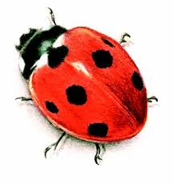

The Brislington Village Ltd Pre-school Dummy policy
Statement of Intent
The Brislington Village Pre-school recognises that babies and young children spend lots of time making sounds and exploring their own mouths and voices before they begin to use words. In doing so they are not only practising and developing the skills needed for speech, but they are also encouraging other people in the world to notice them and communicate with them. Although dummies can be used as a source of comfort for lots of young children, some research has shown that children who suck dummies through the day make fewer sounds, gain less experience of using their voices, and hear less language from adults around them.

Aim

In view of the above information this pre-school aims to limit the amount of time that the children are using their dummy (or bottle).

Method

When a child starts at the setting a form will be completed by the parent/carer (see Appendix A).

Together the setting and the parent/carer will aim to phase out dummies (or bottles) sensitively.

Reviewed September 2018

This policy was adopted on 1st June 2017

Although under constant review, an overall review date has been set for September 2019

Appendix A

Although a dummy can be a source of comfort when a child is upset, and may form part of child’s sleep routine it is our policy that the key person will encourage young children to use a dummy only at these times. The key person will work with parents to phase out dummies and bottles sensitively, taking into account children’s emotional needs.

I, the undersigned parent/guardian of (child’s name)

………………………………………….

do hereby state that I have read and received a copy of the pre-school dummy policy and that my child’s key person or manager has discussed the policy with me.

Child’s Date of Admission

Parent/Guardian

Date

Parent/Guardian

Date

