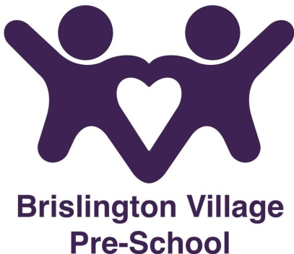

Dummy policy
Statement of Intent
Brislington Village Pre-school recognises that babies and young children spend lots of time making sounds and exploring their own mouths and voices before they begin to use words. In doing so they are not only practising and developing the skills needed for speech, but they are also encouraging other people in the world to notice them and communicate with them. Although dummies can be used as a source of comfort for lots of young children, some research has shown that children who suck dummies through the day make fewer sounds, gain less experience of using their voices, and hear less language from adults around them.

Aims

In view of the above information this pre-school aims to limit the amount of time that the children are using their dummy (or bottle).

Methods

Before a child starts at the setting a record of information form will be completed by the parent/carer, which has space for setting out their child’s needs in relation to dummies (or bottles).

Together the setting and the parent/carer will aim to phase out dummies (or bottles) sensitively.
This policy was adopted on 1st June 2017

Reviewed September 2021

Although under constant review, an overall review date has been set for September 2022

